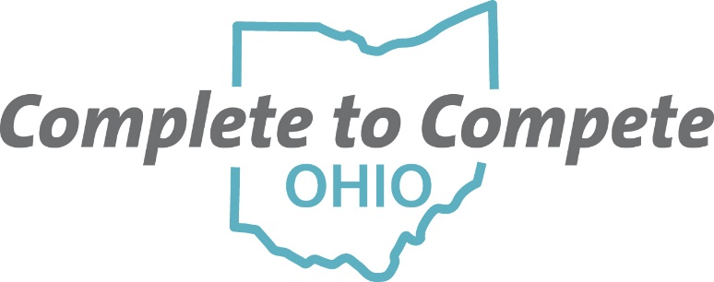

SOCIAL MEDIA
Complete to Compete Ohio is a statewide initiative with the purpose of fostering and sustaining a shared vision to meet Ohio’s attainment goal for 65% of Ohioans to have a degree, certificate, or other post-secondary credential of value in the workplace by 2025. Complete to Compete Ohio has created social media pages on Facebook and Twitter. As a part of this network, help us spread the word about Complete to Compete Ohio by connecting with us on social media.

Like our Facebook page:
Complete to Compete Ohio
https://www.facebook.com/Complete-to-Compete-Ohio-2424367357792296/

Follow us on Twitter:
@OhioComplete
https://twitter.com/OhioComplete

We will also be using hashtags for events and designated posting days. The hashtags help give us brand awareness and alert people to our upcoming events. We are also focusing on FAFSA completion and financial aid on Fridays for the next three months. Here is a list of the hashtags that you may use so that we can connect social media content across organizations and platforms.
- #CompletetoCompeteOH
- #CompletetoCompeteOHSummit
- #FAFSACompletion
- #FinancialAidFriday

